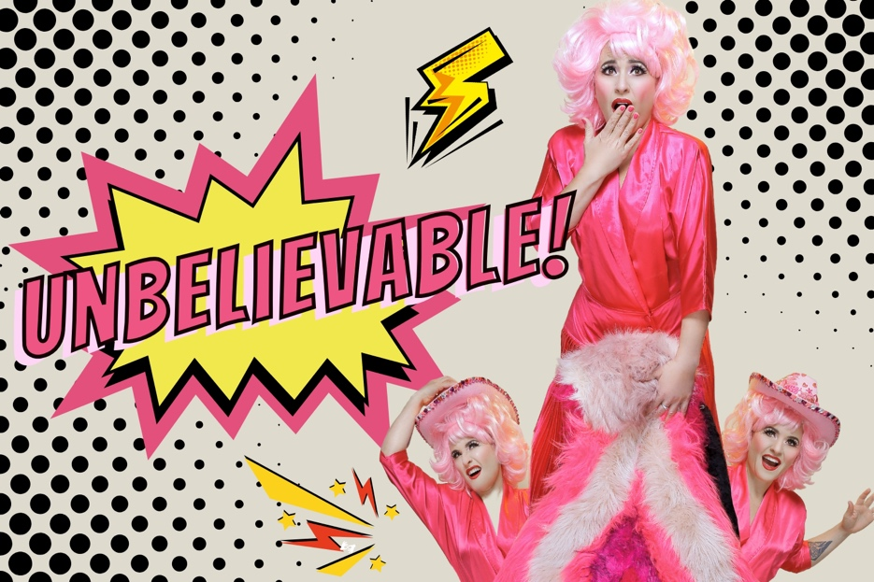The title Unbelievable is in a pop art style, to the left of a very camp image of a light skinned woman in a pink wig a dress.
She’s holding a pink fake fur object and there are two additional images of her in a pink cowboy hat peaking out from behind the fur.

  - NAME OF SHOW: Unbelievable

All dates at Grouse Melbourne
- 3rd Oct 6pm
- 5th Oct 5pm – Auslan interpreted, low sensory, masks encouraged
- 16th Oct 7.15pm
- 17th Oct 7.15pm

  - Duration 55mins
  - (IN APPROX MINUTES)

  - VENUE Grouse Melbourne
ADDRESS: 171 Smith St,
SUBURBL: Fitzroy

Contents Page

Title Page 1
Contents Page 2
The Performers & Characters 4
What to Expect 7
The Space 11
The Venue 12
How to get there 13
Support Resources 14
Feedback 15

The Performers & Characters
Lucy Best | Character + Costume Shot
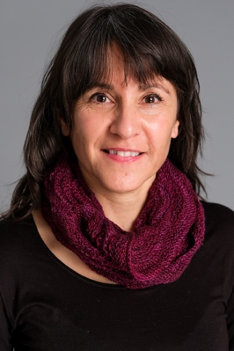  Anna Banana | Lucy Best is the solo performer for the show.  She plays herself. Sharing true stories from her life.  She will be wearing a pink dress.  When she enters she’ll be doing a Kate Bush impression.
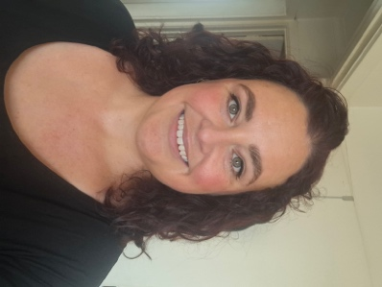 | Kelly Rutter will be the Auslan interpreter on 5th October

Content Advice
Technical Effect Advice | Technical Effect Description
- There will mostly be static lighting while Lucy tells stories  - There are two songs in the show, during which there will be a rainbow chase lighting effect | - There will be ambient lighting in the room and brighter lighting over the performance space  - The rainbow chase will be colourful lighting  - The music in the show will be amplified  - Lucy will project her voice without the use of a microphone
Verbal Content Advice | Verbal Content Description
- The show is mostly talking – storytelling  - The show includes themes of sexual assault, mental health, neurodiversity, queerness, cultural identity, bullying, drugs references, and sexual content  - There will be some course language  - The show is mostly funny but does have some pathos  - There is a story that spans the show, which is about the death of a wild baby dolphin | - Lucy Best will be speaking in English throughout  - She has an English accent  - There is one repeated Spanish phrase  - The first song is a snippet of Kate Bush’s WOW  - The second song is an original song about consent  - The audience is encouraged to join in the songs  - The 5th October show will be Auslan interpreted, low sensory and masks encouraged
Visual Content Advice | Visual Content Description
- Lucy will be clowning and including elements of physical theatre in her performance, however most of the content is delivered from a standing position | - Due to the small performance space the show is not overly physical  - Lucy will use a step ladder to stand on, to create height in the performance  - Lucy is 152cm

What to Expect
For 5th October presentation, you can expect the following features to be available:
Feature | What this Entails | Included | Additional Comments
Consultation with a member of the Neurodivergent arts community | A member of the arts community who identifies as Neurodivergent has been consulted to assess the work and provide feedback on any necessary changes for it to be considered a Low Sensory experience. | Y | The venue and the producer have worked on low sensory shows before and one of the production team is also a neurodivergent artist. As a team we have discussed potential needs and adjustments.
Low sensory translation of the performance lighting | The lighting for the show is augmented to be a low sensory version of a standard showing. | Y | There is no strobe or high contrast lighting in the show.

What to Expect
Continued
Feature | What this Entails | Included | Additional Comments
Addition of the house lights at a low level | The house lights are left on at an “airplane at night-time” level. | Y | Low house lighting will be on.
Open door policy | No lock out, people can come and go as they please. | Y | People can leave the room and take time out if they need a break.
Walkaround policy | People can rock, stim, hum, pace, change seats, and come/go as they need/please. | Y | People are free to move around as and when they need to.  They are welcome to stim and make low volume noise. If they need to be very noisy we will invite them to take a break outside of the performance space.
Open phone policy | Audience can use support devices during the performance.  Recording is discouraged. | Y | People will not be called out if they are using their phone to look at. Photography is fine.
Capped tickets | 85% of total seats available | Y | Reduced to 85%. We will take out as many seats as possible, to give people extra space to move around and stim, make noise etc

What to Expect
Continued
Feature | What this Entails | Included | Additional Comments
Event facilitation by a member of the Neurodivergent arts community | The performance day in question is overseen by an arts professional with lived experience of, and connection with, the Neurodivergent community. | Y | The producer/artist will meet and greet people with FOH staff (who will be briefed), to explain the adjustments made.  At the opening of the show there will also be a reminder that people can move around as they need to.
Confirmed available Quiet Room | A quiet space is available for patrons to use at their discretion. | Y | There is a quiet undercover outside area. There is outside heating if it’s cold.  The space has tables and chairs as well as an open area if people want to be able to move around. If there is noise outside other spaces can be made available.
Extra FOH staff for the event day | Extra staff will be included to help deliver this specific performance. | Y | There will be an additional member of staff supporting the team.
Low sensory translation of the performance Sound | The sound for the show is augmented to be a low sensory version of a standard showing. | Y | The show is already performed without a microphone, so the spoken word elements are at a moderate level.  The music in the show will be a lower volume than at other presentations.

The Space
- There is a mix of flexible unfixed level seating during the show
- The width of space for wheelchairs via all access points is 80cm.
- There is one exit and entrance into the performance space
- It is a room with a bay window
- There is no raised stage

The Venue
- Though the main entrance is not wheelchair accessible, there is an alternative side entrance via Webb Street.
- Venue staff will need to assist by placing a ramp over the single step at the door.
- There are 2 x four hour accessible parking bays directly outside the venue on Webb Street.
- The bathrooms, while size-able, are not fully accessible and dependent on the access requirements.
- There is an accessible toilet located 130m from our venue at 112 Smith Street Collingwood.
- More info/map here... https://toiletmap.gov.au/6596

How to get there
  - PTV
    - Tram – The 86 tram stops on Smith St and gets you the nearest
    - Train – the nearest station is Parliament

  - Parking
    - There is on street parking in the surrounding areas
    - There is a car park at Coles across the street (but it is often full)

  - Drop Off Spots
    - Taxi/Ride Share can drop off on Smith or Webb streets

Support Resources
LGBTIQA+-Specific Support
- QLife: Provides anonymous and confidential peer support and referrals for LGBTIQA+ people via telephone and webchat, operating from 3 pm to midnight every day.
- ACON: A leading LGBTIQ+ health organisation in NSW offering a wide range of services and support, including TransHub, their digital platform for trans and gender diverse people.
- Switchboard Victoria: A community-run service providing peer-based support for LGBTIQA+ individuals and their allies.
- Rainbow Door: A service in Victoria connecting LGBTIQA+ people to different mental health and other support services.
- InterLink: Offers support for people living with innate variations of sex characteristics through trained counsellors and intersex peer workers.
General Crisis and Mental Health Support
- Lifeline:
A 24/7 telephone service providing crisis support and suicide prevention services.
- Beyond Blue:
Offers 24/7 telephone, online chat, and email support for people experiencing anxiety or depression.
- Suicide Call Back Service:
Available 24/7 for anyone experiencing suicidal thoughts or distress.
- headspace: supporting the mental health of young people aged 12-25.

Feedback
For any feedback, questions or concerns please contact Lucy Best: lucy@lucybest

