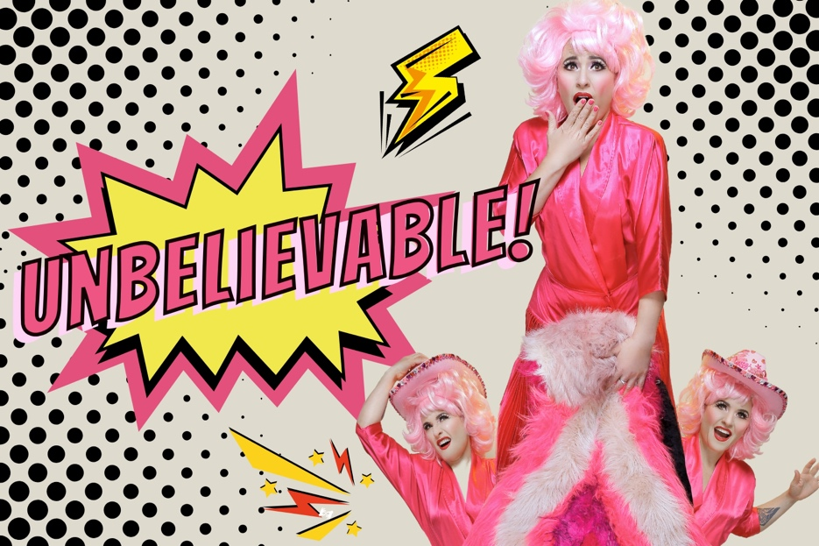The title Unbelievable is in a pop art style, to the left of a very camp image of a light skinned woman in a pink wig a dress.
She’s holding a pink fake fur object and there are two additional images of her in a pink cowboy hat peaking out from behind the fur.

  - NAME OF SHOW: Unbelievable

All dates at Grouse Melbourne
- 3rd Oct 6pm
- 5th Oct 5pm – Auslan interpreted, low sensory, masks encouraged
- 16th Oct 7.15pm
- 17th Oct 7.15pm

  - Duration 55mins
  - (IN APPROX MINUTES)

  - VENUE Grouse Melbourne
ADDRESS: 171 Smith St,
SUBURBL: Fitzroy

Contents Page

Title Page 1
Contents Page 2
The Performers & Characters 4
The Space 7
The Venue 8
How to get there 9
Support Resources 10
Feedback 11

The Performers & Characters
Lucy Best | Character + Costume Shot
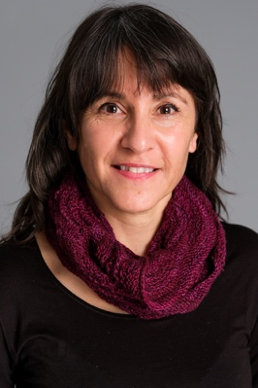  Anna Banana | Lucy Best is the solo performer for the show.  She plays herself. Sharing true stories from her life.  She will be wearing a pink dress.  When she enters she’ll be doing a Kate Bush impression.
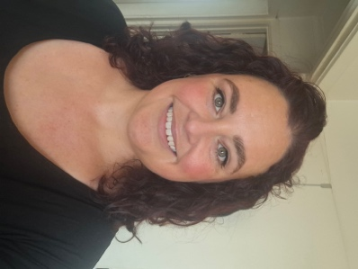 | Kelly Rutter will be the Auslan interpreter on 5th October

Content Advice
Technical Effect Advice | Technical Effect Description
- There will mostly be static lighting while Lucy tells stories  - There are two songs in the show, during which there will be a rainbow chase lighting effect | - There will be ambient lighting in the room and brighter lighting over the performance space  - The rainbow chase will be colourful lighting  - The music in the show will be amplified  - Lucy will project her voice without the use of a microphone
Verbal Content Advice | Verbal Content Description
- The show is mostly talking – storytelling  - The show includes themes of sexual assault, mental health, neurodiversity, queerness, cultural identity, bullying, drugs references, and sexual content  - There will be some course language  - The show is mostly funny but does have some pathos  - There is a story that spans the show, which is about the death of a wild baby dolphin | - Lucy Best will be speaking in English throughout  - She has an English accent  - There is one repeated Spanish phrase  - The first song is Kate Bush’s WOW  - The second song is an original song about consent  - The audience is encouraged to join in the songs  - During the show Lucy will ask the audience a few questions and they’re invited to shout their answers back  - The 5th October show will be Auslan interpreted
Visual Content Advice | Visual Content Description
- Lucy will be clowning and including elements of physical theatre in her performance, however most of the content is delivered from a standing position | - Due to the small performance space the show is not overly physical  - Lucy will use a step ladder to stand on, to create height in the performance  - Lucy is 152cm

The Space
- There is a mix of flexible unfixed level seating during the show
- The width of space for wheelchairs via all access points is 80cm.
- There is one exit and entrance into the performance space
- It is a room with a bay window
- There is no raised stage

The Venue
- Though the main entrance is not wheelchair accessible, there is an alternative side entrance via Webb Street.
- Venue staff will need to assist by placing a ramp over the single step at the door.
- There are 2 x four hour accessible parking bays directly outside the venue on Webb Street.
- The bathrooms, while size-able, are not fully accessible and dependent on the access requirements.
- There is an accessible toilet located 130m from our venue at 112 Smith Street Collingwood.
- More info/map here... https://toiletmap.gov.au/6596

How to get there
  - PTV
    - Tram – The 86 tram stops on Smith St and gets you the nearest
    - Train – the nearest station is Parliament

  - Parking
    - There is on street parking in the surrounding areas
    - There is a car park at Coles across the street (but it is often full)

  - Drop Off Spots
    - Taxi/Ride Share can drop off on Smith or Webb streets

Support Resources
LGBTIQA+-Specific Support
- QLife: Provides anonymous and confidential peer support and referrals for LGBTIQA+ people via telephone and webchat, operating from 3 pm to midnight every day.
- ACON: A leading LGBTIQ+ health organisation in NSW offering a wide range of services and support, including TransHub, their digital platform for trans and gender diverse people.
- Switchboard Victoria: A community-run service providing peer-based support for LGBTIQA+ individuals and their allies.
- Rainbow Door: A service in Victoria connecting LGBTIQA+ people to different mental health and other support services.
- InterLink: Offers support for people living with innate variations of sex characteristics through trained counsellors and intersex peer workers.
General Crisis and Mental Health Support
- Lifeline:
A 24/7 telephone service providing crisis support and suicide prevention services.
- Beyond Blue:
Offers 24/7 telephone, online chat, and email support for people experiencing anxiety or depression.
- Suicide Call Back Service:
Available 24/7 for anyone experiencing suicidal thoughts or distress.
- headspace: supporting the mental health of young people aged 12-25.

Feedback
For any feedback, questions or concerns please contact Lucy Best: lucy@lucybest

